71. Slotted Aloha

Outcomes of the lecture are

1. Types of Aloha.
2. Slotted Aloha.

Difference between Pure aloha and Slotted Aloha for better Understanding.

Pure Aloha Slotted Aloha

|  |  |
| --- | --- |
| In this Aloha, any station can transmit the data at any time. | In this, any station can transmit the data at the beginning of any time slot. |
| In this, The time is continuous and not globally synchronized. | In this, The time is discrete and globally synchronized. |
| Vulnerable time for Pure Aloha = 2 x Tt | Vulnerable time for Slotted Aloha = Tt |
| In Pure Aloha, Probability of successful transmission of the data packet  = G x e-2Greduce | In Slotted Aloha, Probability of successful transmission of the data packet  = G x e-G |
| In Pure Aloha, Maximum efficiency  = 18.4% | In Slotted Aloha, Maximum efficiency  = 36.8% |
| Pure Aloha doesn’t reduces the number of collisions to half. | Slotted Aloha reduces the number of collisions to half and doubles the efficiency of Pure Aloha. |

Pure Aloha

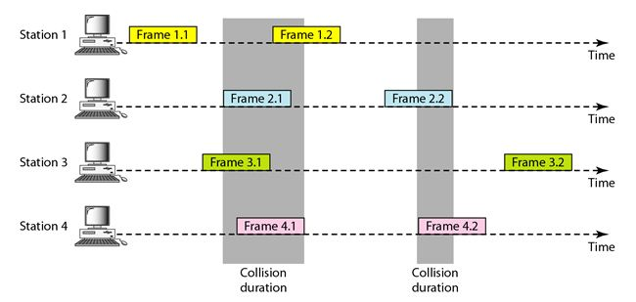

Slotted Aloha

